Jägermeister Day
&
Schnapps Fest

July 21, 2019 3:30 – 6:30 PM

Music by the Button Box Committee

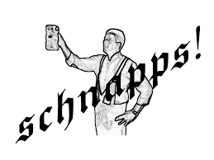
Schnapps
Specials

Food Specials
Lulu’s Famous Chicken Paprikas & Halupkis

Open to the public -Addmission $3.00

