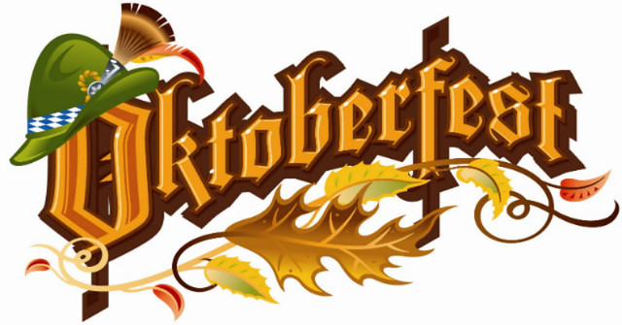

September 15, 2019 3:30 – 6:30 PM
Plus
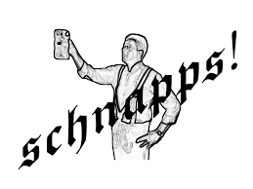
Schnapps Fest
(Schnapps Specials)

Music by Josef Kroboth
With
The Auerhahn Schulplatters

German Food Specials

Open to the public -Addmission $3.00

